**Audio Fingerprinting**

Song Matching:

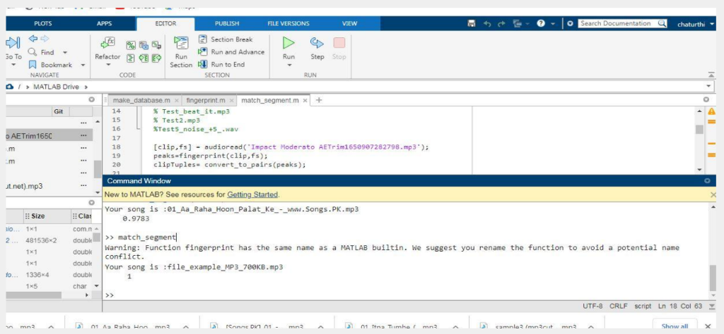

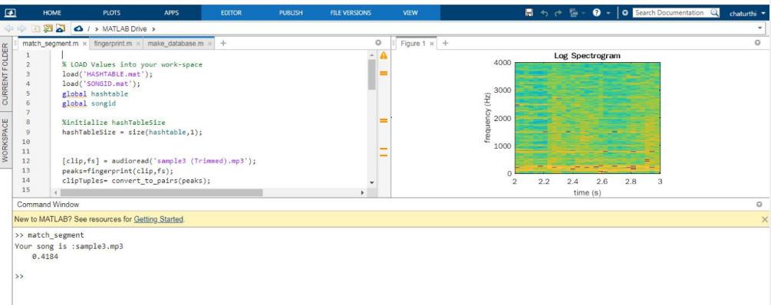

Matlab is used as a numerical computing environment

Matplotlib is a python library and we used it for visualizations and plotting for

system analysis

● import hashlib

● import numpy as np

● import matplotlib.pyplot as plt

● from matplotlib.mlab import specgram

● from scipy.io import wavfile

● from skimage.feature import peak_local_max

Applications:-

1. Music Retrieval

Music recognition is an integral application of audio fingerprinting. The

specific feature of a song or music signal is captured as a fingerprint.

eg.Shazam Application.

2. Watermarking

Audio fingerprinting allows the signal processing approach to

generate the digital signature

3. Broadcast Monitoring

4. Voice Identification – For Automotive Use-case

automatic music library organization using genre classifications, music

trainer using vocal analysis, audio geographical mapping, etc.